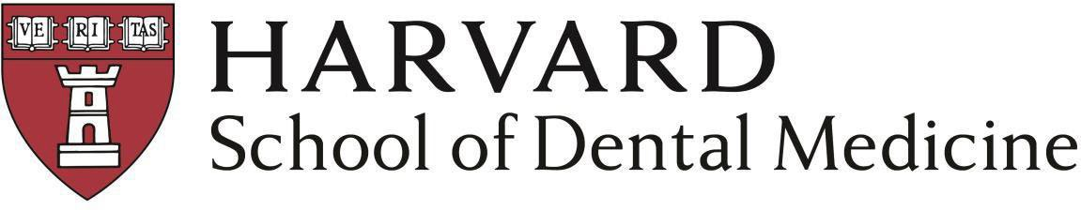

Advanced Education General Dentistry (AEGD) - Rural Track:

Application Requirements

Deadline for Application: February 1, 2025

Submitted to ADEA PASS:
- Personal Statement
- CV/Resume
- Dental School Transcript
- All College Transcripts
- Transcript Evaluation (if applicable)
- Institutional Evaluation Form
- Professional Evaluation Form 1
- Professional Evaluation Form 2
- Professional Evaluation Form 3
- Official TOEFL Scores*
- Official NBDE/INBDE scores (required for all applicants)

Submitted to HSDM:
- HSDM Supplemental Application
- $95 non-refundable application fee can be paid here
- Each resident must hold a DDS or DMD from a CODA-accredited dental school by the time of enrollment, must be either a U.S. citizen or permanent resident, and must be eligible to hold a New Hampshire dental license.
- NBDE/INBDE scores are not required at the point of application, but must be submitted prior to matriculation.
- IEF is required; we will accept one from a program completed after dental school such as a specialty program. This can be from a Principal Investigator. One of the PEFs must be from your most recent academic director and/or employer (if applicable).
- *Any applicant whose native language is not English is required to submit TOEFL scores from a test taken within the past two years. The TOEFL exam can only be waived if BOTH the bachelor's degree and dental degree were obtained in the United States, Canada, Australia, Ireland, or the United Kingdom. The minimum acceptable overall score is 95, with subcategory score minimums of Reading 21, Listening 17, Speaking 24, and Writing 25. All subcategory score minimums must be satisfied.

NOTE: Please do not submit any of the following to HSDM: transcripts, resumes/CVs, letters of recommendation, portfolios, research papers, etc. All materials submitted to PASS will suffice for the application process.

